**ADDITON TO WORK-POOL IN LIS**

**Add new test type IgG (Virus)**

**Allergen code IVG**

Automatically add allergen code A999 to each test ordered in work-pool

e.g. If we run dilutions:

Panel: IVG1, IGV2 and IGV3

IVG1 (dilution 1)

IVG2 (dilution 1) same source position as above

A999 added

IVG3 (dilution 2)

IVG4 (dilution 2) same source position as above

B999 added

IVG5 (dilution 3)

IVG6 (dilution 3) same source position as above

C999 added

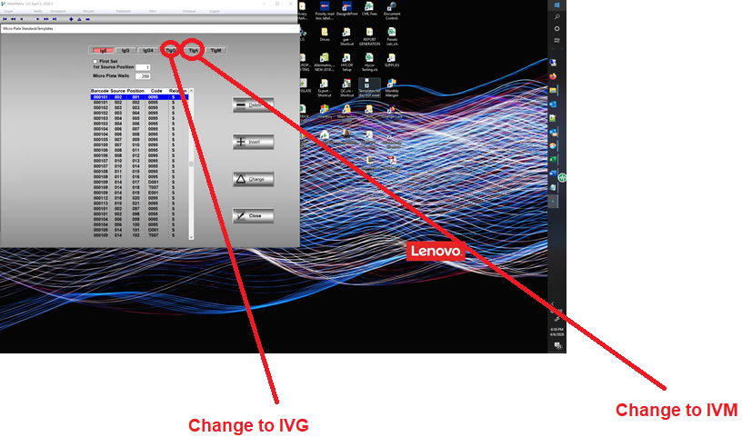

**Add new test type IgM (Virus)**

**Allergen code IVM**

Same as IGV above